**M04-UF2-PR01**

**Validació de RSS:**

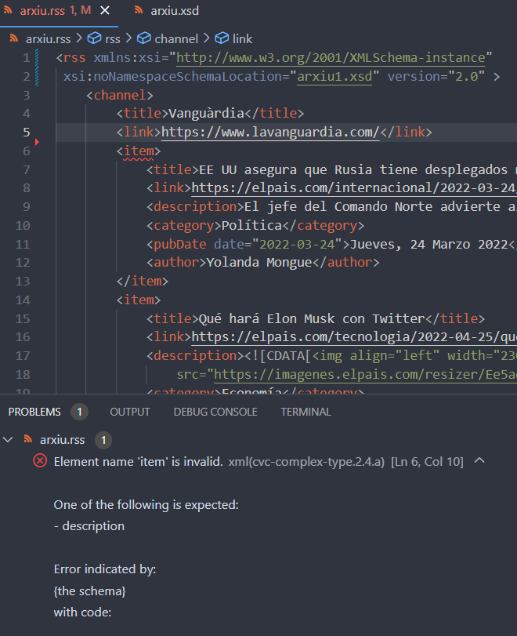

**Consultes xPath:**

**Consulta (a.)**

//channel/item/pubDate[@date > "2022-10-31" and @date < "2023-3-1"]/../title

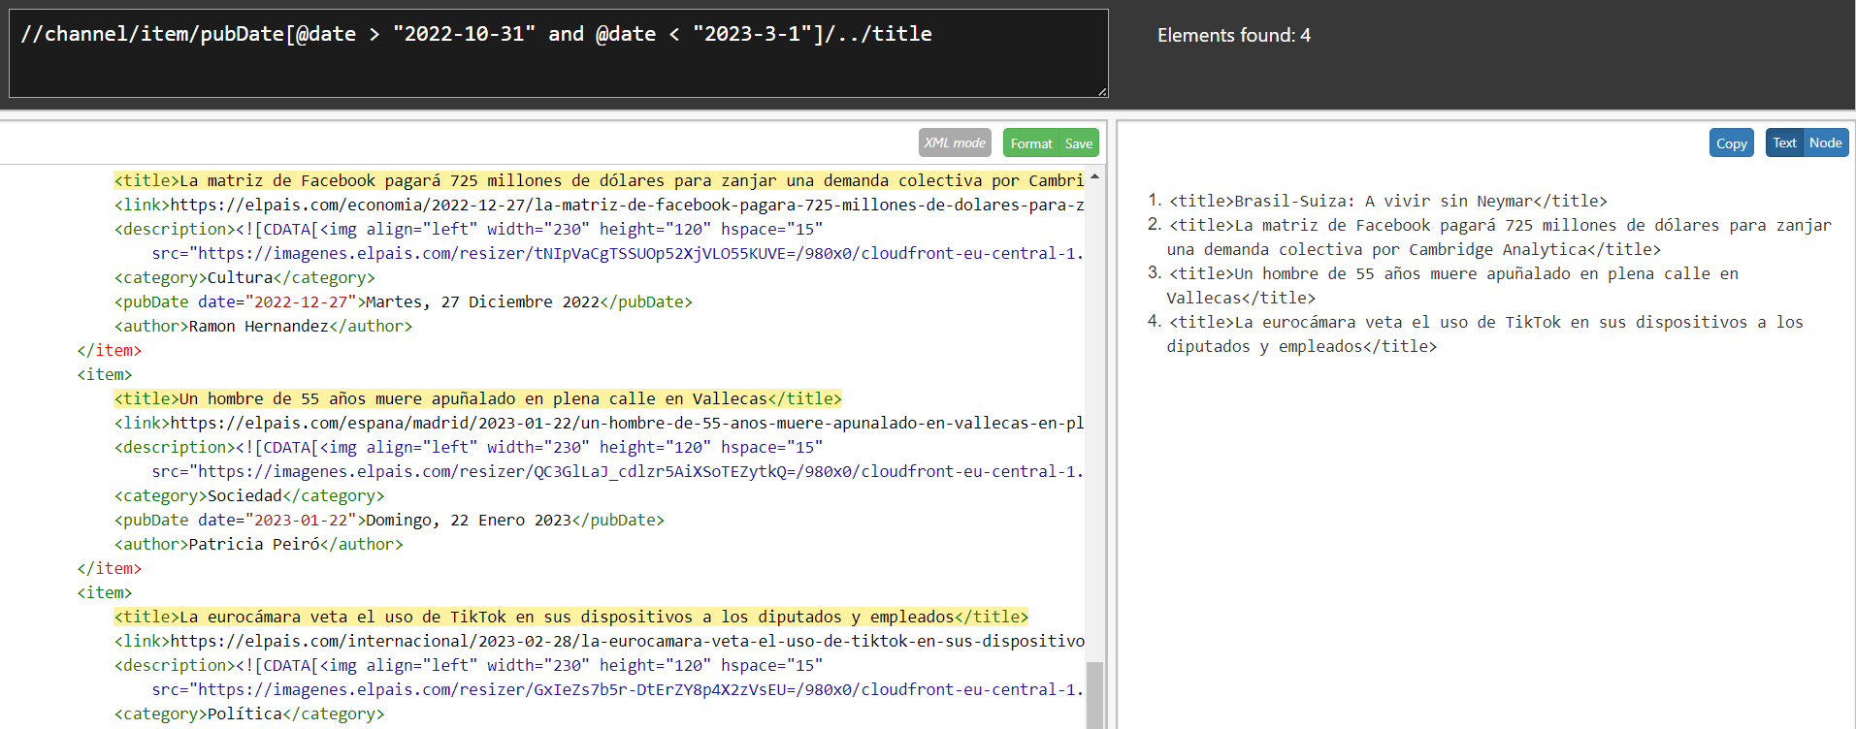

**Consulta (b.)**

//channel/item/pubDate[year-from-date(@date)=//channel/item[category="Deportes"][1]/pubDate/year-from-date(@date)]/text()

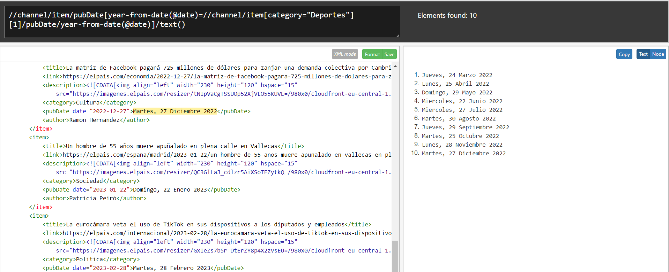

**Consulta (c.)**

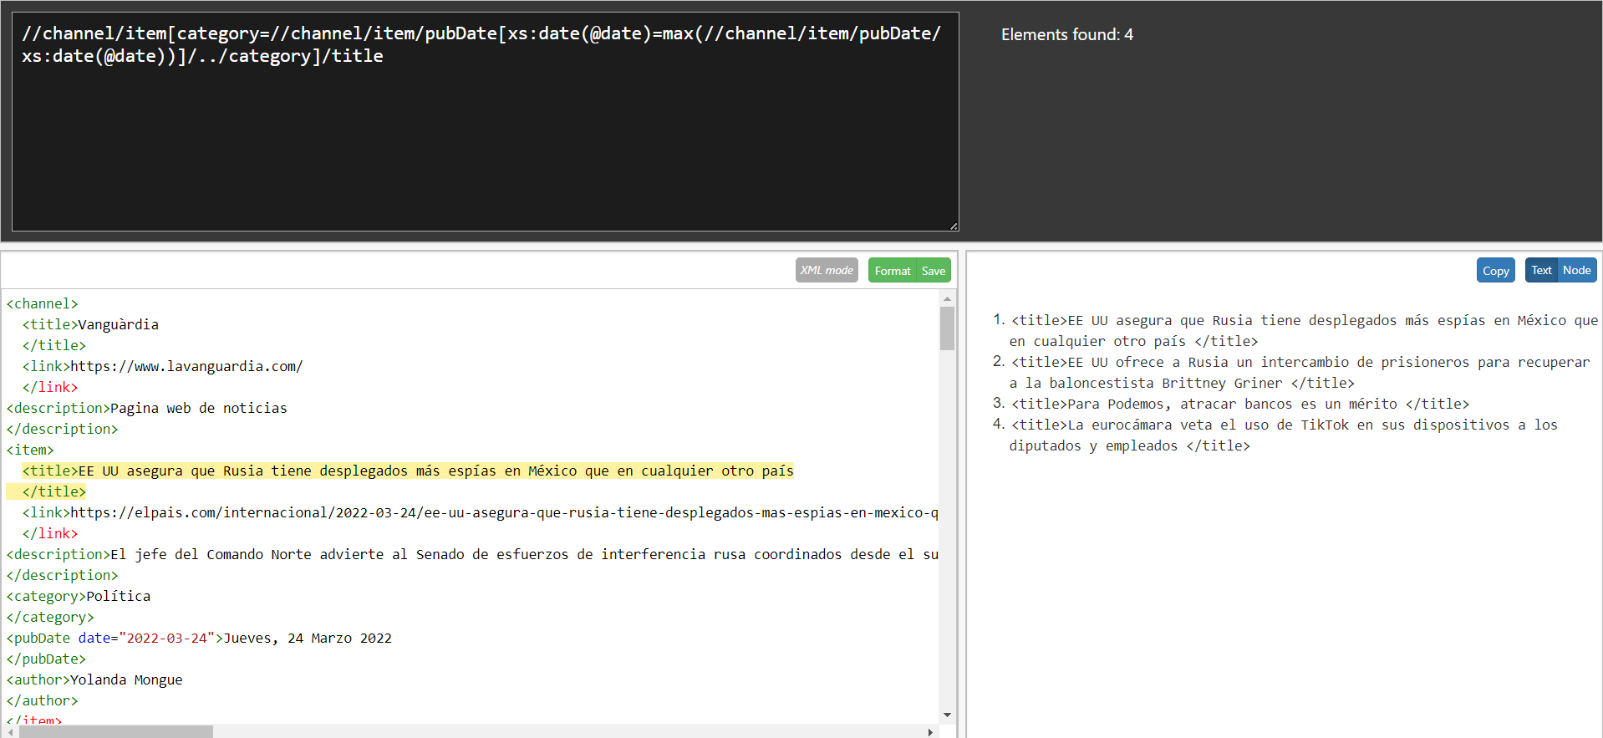

**Consulta (d.)**

